Assignment 29.1

Problem Statement:

Write a hive UDF that implements functionality of string concat_ws(string SEP, array). This UDF will accept two arguments, one string and one array of string. It will return a single string where all the elements of the array are separated by the SEP.

Creating UDF class

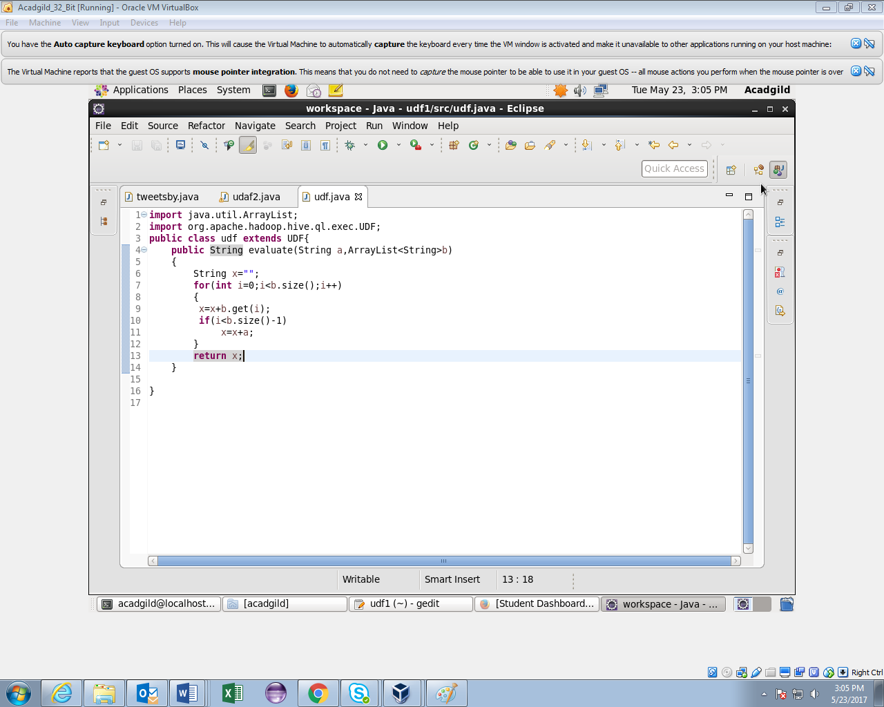

Creating table and loading data in it.

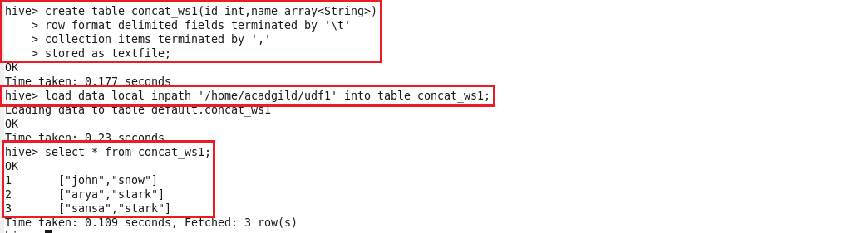

Creting temporary function and using UDF.

